



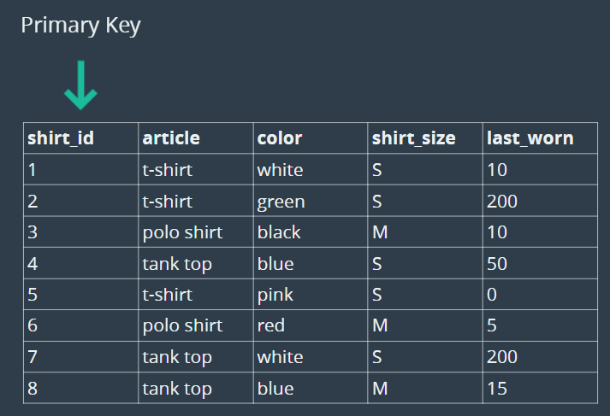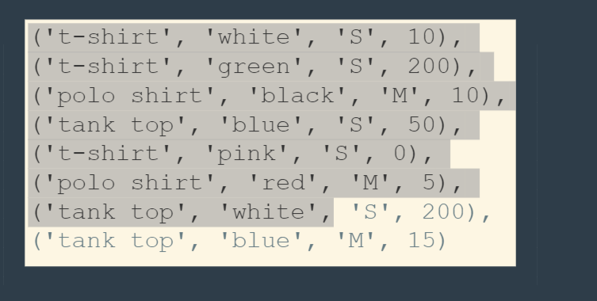





















The Solutions:

create database shirts_db;

use shirts_db;

create table shirts(

shirt_id int auto_increment primary key,

article varchar(100),

color varchar(100),

shirt_size varchar(4),

last_worn int

);

desc shirts;

insert into shirts(article, color, shirt_size, last_worn)

values('t-shirt', 'white', 'S', 10),

('t-shirt', 'green', 'S', 200),

('polo shirt', 'black', 'M', 10),

('tank top', 'blue', 'S', 50),

('t-shirt', 'pink', 'S', 0),

('polo shirt', 'red', 'M', 5),

('tank top', 'white', 'S', 200),

('tank top', 'blue', 'M', 15);

select * from shirts;

insert into shirts(article, color, shirt_size, last_worn)

values('polo shirt', 'purple', 'M', 50);

select * from shirts;

select article, color from shirts;

select article, color, shirt_size, last_worn from shirts where shirt_size='M';

update shirts set shirt_size = 'L' where article = 'polo shirt';

select * from shirts;

update shirts set last_worn = 0 where last_worn = 15;

select * from shirts;

update shirts set shirt_size = 'XS', color = 'off white' where color = 'white';

select * from shirts;

delete from shirts where last_worn = 200;

select * from shirts;

delete from shirts where article = 'tank top';

select * from shirts;

delete from shirts;

select * from shirts;

drop table shirts;